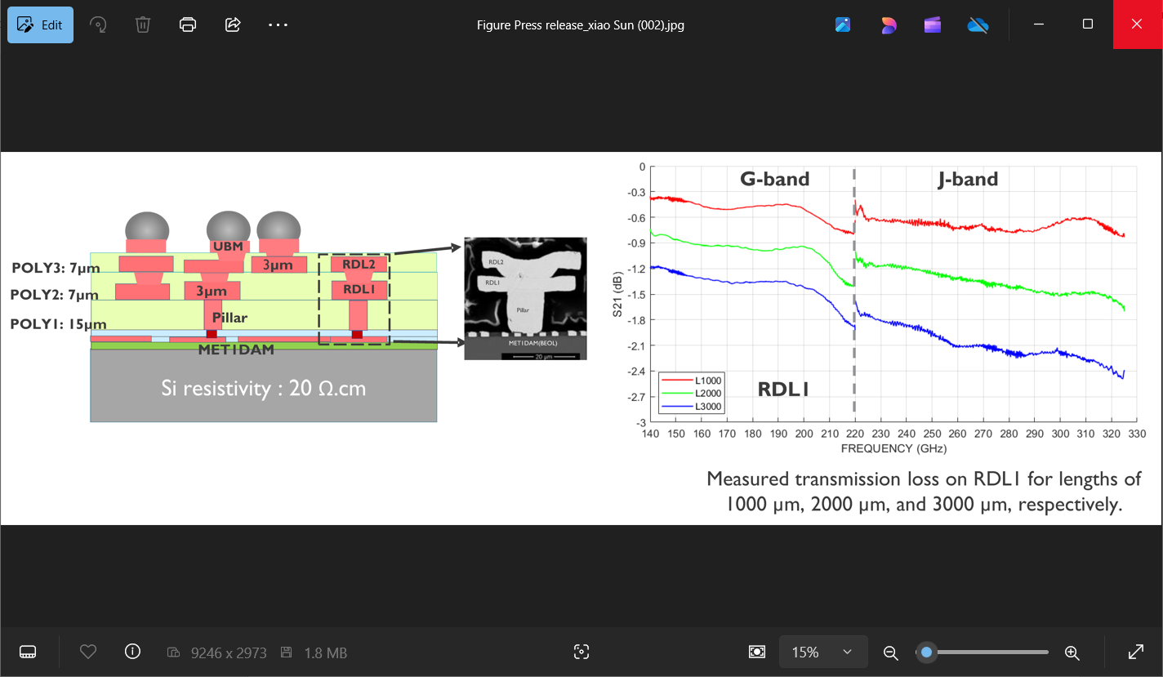

1. (b)

**300mm RF Interposer with Integrated Digital and mmWave Interconnects**: SiGe and III-V technologies have better power efficiency and gain at mmWave frequencies than scaled CMOS nodes, while CMOS offers the best power efficiency for digital applications. Therefore, for high-performance RF communications and sensing applications, heterogeneous integration of chiplets brings many advantages. A key requirement, though, is the ability to integrate mmWave and digital interconnects on a single carrier for optimum performance and cost-effectiveness.

At ECTC, IMEC researchers will describe how they did just that. They built a state-of-the-art 300mm RF Si interposer platform with integrated interconnects, optimized for heterogeneous integration of chiplets in mmWave and sub-THz applications. Compared to earlier work, it demonstrated reduced losses up to sub-THz frequencies (0.23 dB/mm at 140 GHz, 0.5 dB/mm at 220 GHz, and 0.73 dB/mm at 325 GHz for RDL2), which is state-of-the-art performance. The digital links use Cu damascene BEOL layers, while the mmWave links employ transmission lines on a low-loss polymer, enabling the integration of RF-to-sub-THz CMOS and III/V chiplets. Also, high-quality passive components were incorporated on the interposer to reduce active chip area, cutting costs and providing compact, low-loss RF interconnects. Built on a 300mm wafer, the researchers say this innovation is scalable for cost-effective, high-volume manufacturing.

Above:

1. is a cross-section of the RF Si interposer, consisting of a standard low-resistivity Si substrate, a full ground shield, three spin-coated low-RF loss polymer layers (POLY 1-3), three thick metal layers (RDL1, RDL2 and UBM), and microbumps.
2. shows the insertion loss of 1mm, 2mm and 3mm-long microstrip lines on RDL1: G-band and J-band.

**(Paper 5.6, “*RF Si Interposer Platform for Chiplet-based Heterogenous Systems*,” X, Sun et al, IMEC)**